C29PE Tutorial 8 Questions and Solutions - Macroeconomic Equilibrium and Policy

- If a household earns £200 a week and spends £150 each week on domestically produced goods and services.

  - How much does it withdraw from the circular flow? £50

  - What forms will these withdrawals take? Saving, net taxes, expenditure on imports

  - Assume that aggregate household income rises from £500bn to £550bn. Assume that this results in the consumption of domestically produced goods and services rising from £450bn to £490bn. What is the mpc_{d}?
ΔC_{d} / ΔY = £40bn/£50bn = ⁴/₅ or 0.8

  - Assuming that the mpc_{d} remains constant, find the equilibrium level of consumption of domestically produced goods and services if national income now rises to £700bn?
If national income rises from £550bn to £700bn, a rise of £150bn, then C_{d} must rise by ⁴/₅ of this (= £120bn) from £490bn to £610bn.

  - Were total consumption of domestically produced goods and services £490bn with injections into the circular flow of income of £80bn, what will be the level of aggregate expenditure (E)? £490bn + £80bn = £570bn

  - Given your answer to (e), and assuming that total household incomes are currently £550bn, what will happen to household income? Rise to £570bn

  - What is the formula for the marginal propensity to withdraw? ΔW/ΔGDP

  - What are the answers to the following? (Use a number or another term as appropriate.)
    - GDP – W = C_{d}
    - mpc_{d} + mpw = 1

- In a closed economy (i.e. one that does not engage in foreign trade), spending on consumer goods is related to GDP by the following schedule:

GDP (£bn) | 0 | 20 | 40 | 60 | 80 | 100 | 120 | 140 | 160 | 180
C_{d} (£bn) | 4 | 20 | 36 | 52 | 68 | 84 | 100 | 116 | 132 | 148
J (£bn) | 20 | 20 | 20 | 20 | 20 | 20 | 20 | 20 | 20 | 20
E (£bn) | 24 | 40 | 56 | 72 | 88 | 104 | 120 | 136 | 152 | 168

  - If firms are investing at a rate of £8bn per year and the government is spending £12bn per year, fill in the figures in the table for total injections (J) and aggregate expenditure (E).

  - What is the equilibrium level of GDP? £120bn

  - What is the mpc_{d}? ⁴/₅ or 0.8

  - What is the value of the expenditure multiplier? 5

  - Suppose that full employment yields a GDP of £140bn per annum, by how much must government expenditure be changed to reach full-employment GDP?
Raised by £4bn (with a multiplier of 5, this will lead to the required rise in national income of £20bn)

  - Does the initial equilibrium situation represent an inflationary or a deflationary gap, and what is the size of this gap?
Deflationary gap. The size of the gap is £4bn.

- When calculating real GDP we must use the GDP deflator for that year. This allows us to adjust figures measured in current prices for the rate of inflation, and show them in terms of a base year. Assuming that GDP in current prices grows from £120 billion in year 1 to £160 billion in year 2 and that the GDP deflator rises from 100 in year 1 to 130 in year 2, by how much has real GDP grown? 2.56%
This is calculated as follows: Real GDP = Nominal GDP/GDP deflator × 100.
Thus in year 1, real GDP = £120bn/100 × 100 = £120bn
and in year 2, real GDP = £160bn/130 × 100 = £123.07bn
real GDP has grown by (123.07 – 120)/120 × 100 = 2.56%

Sample exam questions

- You are given a model of aggregate demand for a closed economy, so exports X=0 and imports M = 0. You have variables National income (GDP) Y, aggregate consumption, C, savings, S, investment, I, government expenditure, G, net taxation T, and disposable income, YD = Y-T with:
C = 0.8YD
T= 0.125Y
G = 1,500, I = 600,
  - State the two versions of the equilibrium condition which must hold, using both words and symbols.
Y = AE, W = J
  - By obtaining an expression for savings in terms of national income, demonstrate that in equilibrium, national income Y* = 7000.
S = Yd – C = Yd – 0.8Yd = 0.2Yd = 0.2 (Y – 0.125Y) = 0.175Y.
W = S + T = 0.175Y + 0.125Y = 0.3Y
J = 1500 + 600 = 2100
In equilibrium, W = J 2100 = 0.3Y Y = 7000
  - The government estimates the full employment level of national income to be YF = 7600, and that it proposes to close that gap by increasing government spending. Given the marginal propensity to consume out of domestic income, mpcd = 0.7, calculate the required increase in government spending.
Since current income = 7000, income needs to increase by 600.
ΔY = Expenditure multiplier X ΔG
Expenditure multiplier = 1/(1 – 0.7) = 1/0.3 = 3.3333
So, ΔG = 600/3.3333 = £180bn

- You are given the following information on an open economy:

Consumer expenditure = 100 + 0.8Y
Investment expenditure = 600
Government expenditure = 1000
Exports = 500
Imports = 0.3Y
There are no taxes

- Calculate the equilibrium level of income.

In equilibrium, Y = C + I + G + X – M
So, Y = 100 + 0.8Y + 600 + 1,000 + 500 – 0.3Y;
and 0.5Y = 2,200, so that Y = 4,400.

- Suppose that the government believes that the full employment level of income Y* = 4,800. It proposes to reach that level by encouraging investment.

  - Explain briefly why the increase in national income after an increase in investment is larger than the increase in investment.

Since higher investment involves the production of goods and services, payments to suppliers of factor inputs, including labour, increase. Household consumption will increase, increasing national income by more than investment.
  - The multiplier, m = ΔY/ΔI, is a measure of the extent to which national income increases relative to the increase in investment. State the relationship between the multiplier and the marginal propensity to withdraw income from the circular flow, and then calculate the value of the investment multiplier in this example.

Multiplier, m, is the inverse of the marginal propensity to withdraw, MPW, so m = (MPW)⁻¹. Here MPW = 0.5, so m = 2.

  - By how much should investment increase if the economy is to reach its full employment level of national income, Y* = 4,800?

The unemployment gap is 400, and the multiplier is 2, so that the gap can be closed by increasing investment by 200.

Supplementary questions (will not be discussed in class)

- 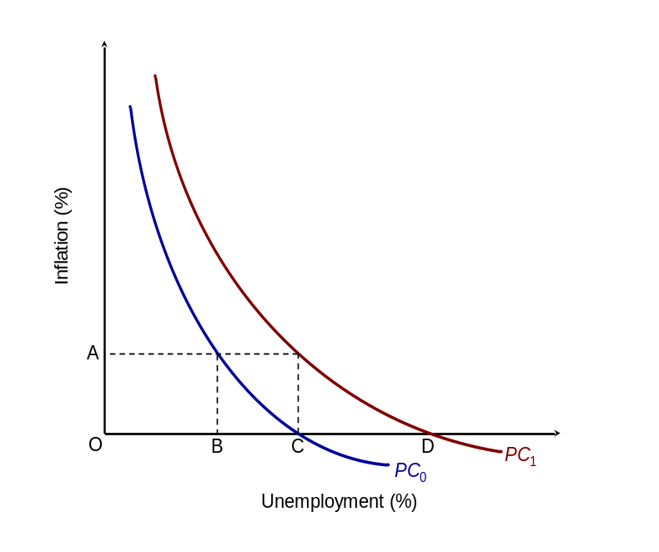The diagram opposite shows two short-run Phillips curves (PC₀ and PC₁). PC₀ corresponds to a situation in which workers expect no inflation.

  - What is the natural rate of unemployment? C

  - (b) What is the expected rate of inflation if the Phillips curve is PC₁? A

  - Suppose that the economy begins in long-run equilibrium with zero inflation and that the authorities adopt a policy of constant monetary growth because they wish to reduce unemployment below its existing level.

    - Identify the short-run effect on unemployment and inflation.
Unemployment falls from C to B
Inflation rises from zero to A

    - Explain why this new position for the economy is untenable in the long run.
Because inflationary expectations will rise, and thus the short-run Phillips curve will keep shifting upwards, as long as unemployment is kept below the natural rate, C.

    - Towards what long-run equilibrium level of unemployment will the economy tend? The natural rate – C

- The public-sector deficit or surplus will be influenced by the level of national income.
  - Explain how increasing national income is likely to affect the public sector budget balance.
As national income rises, tax revenue also rises. This reduces the deficit. However there will also be a reduction in automatic stabilisers, such as social benefits paid to the unemployed (assuming that the increase in national income is rapid
Budget balance
B₂
B₁
Y₂
Y₁
National income

enough that unemployment will fall). With both effects, the budget deficit will fall (or the surplus rise). The opposite will happen if national income falls.

    - What will determine the rate at which the budget balance changes with income?
The marginal tax rate and the marginal benefit reduction rate.

    - What might cause the budget balance to decrease at all levels of national inocme?
Either a reduction in taxes or an increase in government expenditure, including benefits.

  - The diagram above shows the relationship between national income and the government’s budget balance (BB).

    - Define the term ‘budget balance’.
Government revenue (e.g. tax revenue) minus government expenditure

    - Describe the budgetary position at Y₁.
A deficit of B₁ (budget balance is less than zero).

    - Assume that full employment is achieved at Y₂, what is the size of the structural budget balance?
A surplus of B₂

    - If national income remains at GDP₂, and the BB line does not shift, what will happen to the level of national debt?
It will fall, since the budget surplus can be used to pay back government debt.

- Give three reasons why it is difficult to forecast the magnitude of the impact of fiscal policy on the economy.
- The amount of crowding out is difficult to predict.
- The impact of tax cuts (or benefit increases) will depend on how consumers decide to allocate additional incomes (which in turn depends on expectations of future price and income changes).
- The size of the accelerator is difficult to predict and subsequent multiplier/accelerator interactions are virtually impossible to predict.
- Random shocks will also create difficulties in assessing the impact of fiscal policy on the economy.

- There is always debate about how changes in government spending will affect national income. On separate AD/AS diagrams illustrate the following scenarios:
(i) an increase in government spending which is entirely crowded out;
(ii) an increase in government spending which increases business confidence and induces a rise in investment expenditure.

In the first scenario the increase in government spending is completely offset by a decrease in private-sector spending. Hence, in the diagram, the AD curve remains at AD₁. This may be because of resource crowding out, i.e. the public and private sectors competing for resources such as labour and raw materials, and/or financial crowding out, i.e. the public sector diverting sources of finance away from the private sector.
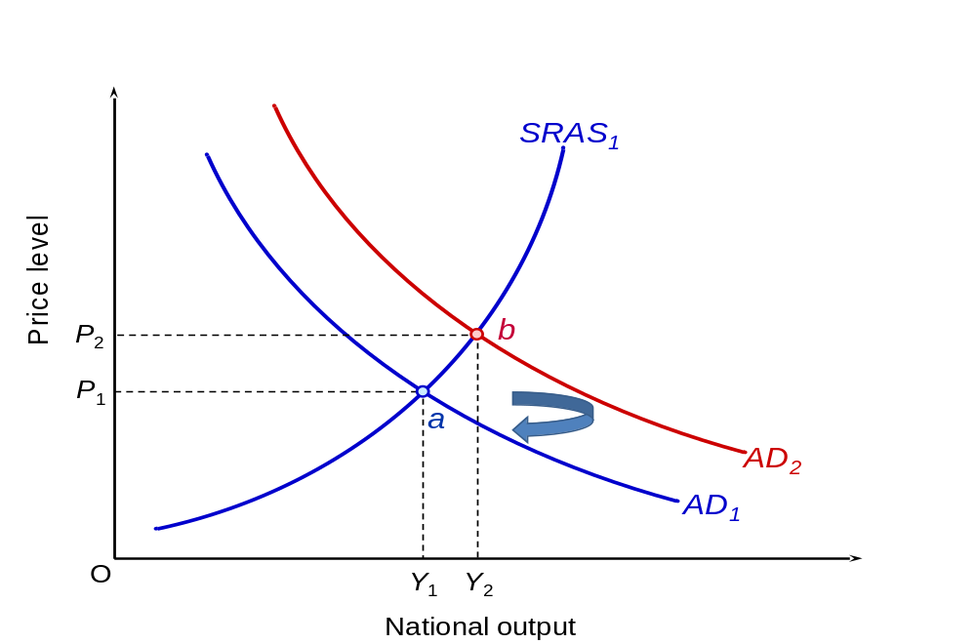
In the second scenario the increase in government spending helps to induce additional private-sector spending in the form of investment (I). Hence, the AD curve moves from AD₁ to AD₃. The move from AD₂ to AD₃ captures the additional private-sector spending following the increase in government spending which itself is captured by the move from AD₁ to AD₂. The increase in investment spending not only affects the AD curve but also results in the SRAS curve moving rightwards to SRAS₂. The result is that national income increases from Y₁ to Y₃ with the size of increase depending on the extent of the rightward shifts in the AD and SRAS curves from the increased investment spending.

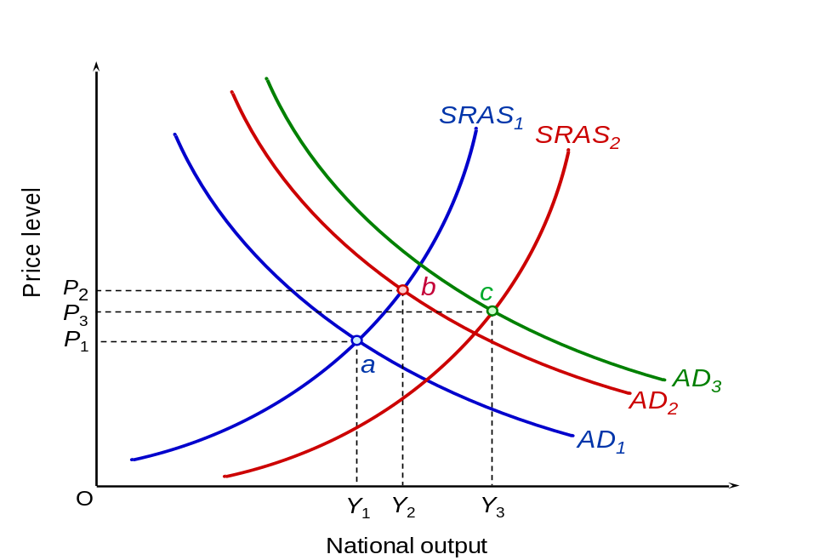

- Assume that there is a substantial rise in oil and other commodity prices and inflation is forecast to rise considerably above the 2 per cent target. As a result the Bank of England raises interest rates. Which of the following might be a consequence of such a policy?

  - Reduced investment Yes / No
  - A deteriorating competitive position overseas Yes / No
  - Increased costs of production Yes / No
  - Slower growth in potential output Yes / No
  - Increased cost to the government in servicing the national debt Yes / No
  - Increased cost-push pressures Yes / No

All are possible consequences of a policy of high interest rates. Note that in case of (b), higher interest rates will lead to an appreciation of the exchange rate, which will make exports and home-produced import substitutes less competitive. In the case of (d), higher interest rates will discourage investment, which will reduce the rate of growth of capital and of technical progress.

- It has become fashionable for governments to set rules for important economic variables such as the rate of inflation and the size of government deficits. Others prefer more active monetary and fiscal policies which align policy with economic circumstances.
  - Briefly outline the case for ‘rules’.
They help to reduce the expected rate of inflation and create a stable environment for investment and growth. Discretionary policy, by contrast, owing to time lags and uncertainty, will at best be ineffective, and at worst actually destabilise rather than stabilise the economy.
  - Briefly outline the case for discretion.
Keynesians tend to favour discretion because the economic environment is always changing; hence government must change its policy in response. Better forecasting and speedier action will help to increase the effectiveness of discretionary policy.

- Which of the following measures to cure unemployment would we call supply-side and which demand-side solutions, and which have elements of both? [You may find it useful to think of supply side effects as increasing the productivity capacity of the economy].

  - The encouragement of pay restraint to keep costs down by preventing excessive wage increases. Supply-side

  - The launch of a new government training programme for school leavers.
Supply-side

  - A new computer network is set up to provide more detailed national information at job centres on vacancies. Supply-side

  - A government investment programme targeted on key growth industries.
Both – Investment will stimulate aggregate demand, but it will also increase potential output and/or reduce costs by increasing the capital stock, especially if investment is targeted on key growth industries or to bottleneck sectors.

  - Income tax is cut by 2p in the pound.
Both - Tax cuts, as well as stimulating aggregate demand, will also offer an incentive for workers to work (assuming the substitution effect outweighs the income effect).

  - Lower interest rates to prevent the exchange rate appreciating.
Demand-side - Lower interest rates will increase demand generally, and a lower exchange rate will increase the demand for exports at existing sterling prices. A lower exchange rate, however, will not reduce costs.

